Question list about Scrum 4:

* Questions (from Jin):
* Questions (from Ying & Jingyi):
  + Is there any provided document template?
  + Include what type of documents? User manual
* Questions (from Emily)
  + Video--demo
* Questions (from Eric):
  + Report: Do you satisfy with the current way of presentation?
  + Documentation: What is the target reader of the documentation?
* Questions (from Peter):
  + Is there something that we need to improve? Or not satisfied?
* Questions (from Qi Long):

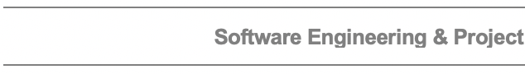

**Snapshot Week 3 of Group SMU6**

Staff Management Utility

## 

## Jin Yin (a1761810)

Jingyi Cui(a1787453)

## Ka Yiu Eric Ma (a1792052)

## Qi Long (a1763385)

## Xinquan Jiang (a1753115)

## Yingyao Lu (a1784870)

## Ying Li (a1776903)

## Yucheng Geng (a1756633)

## Zihe Wang (a1684198)

**Product Backlog and Task Board:**

The product backlog:

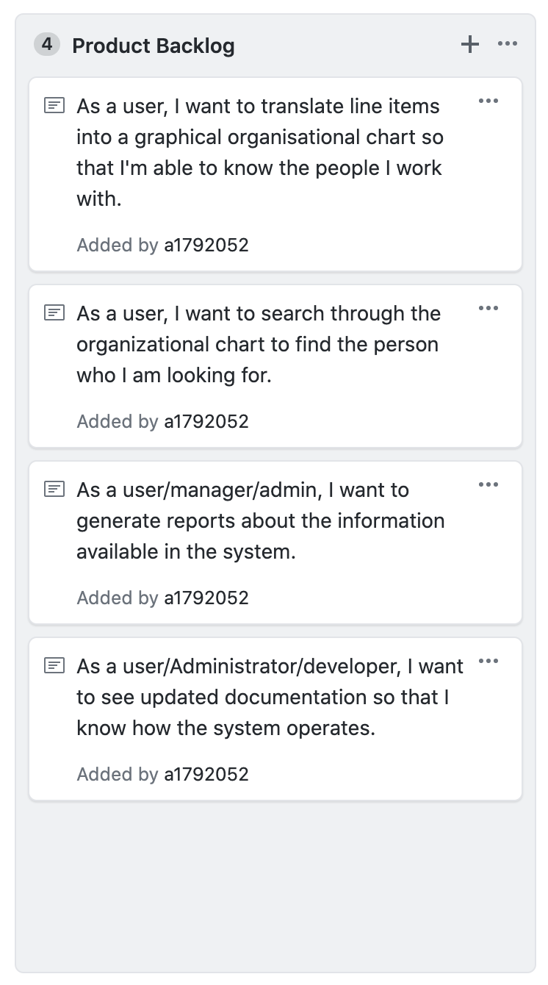

The task board:

* To do:

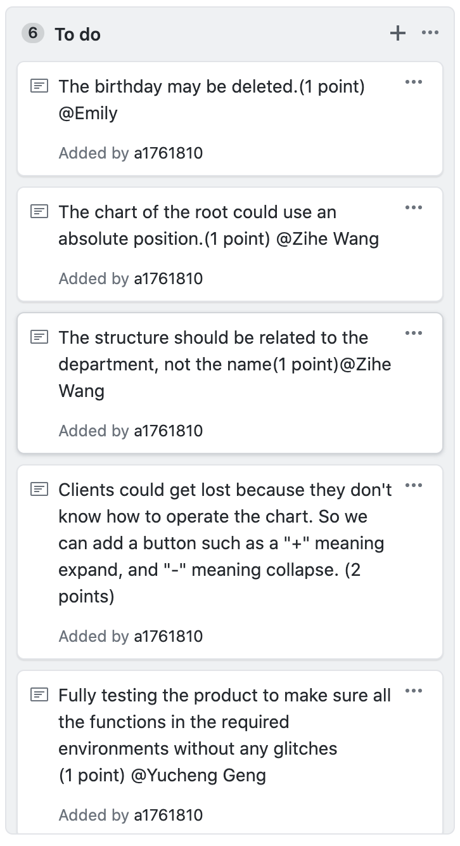

* Doing:

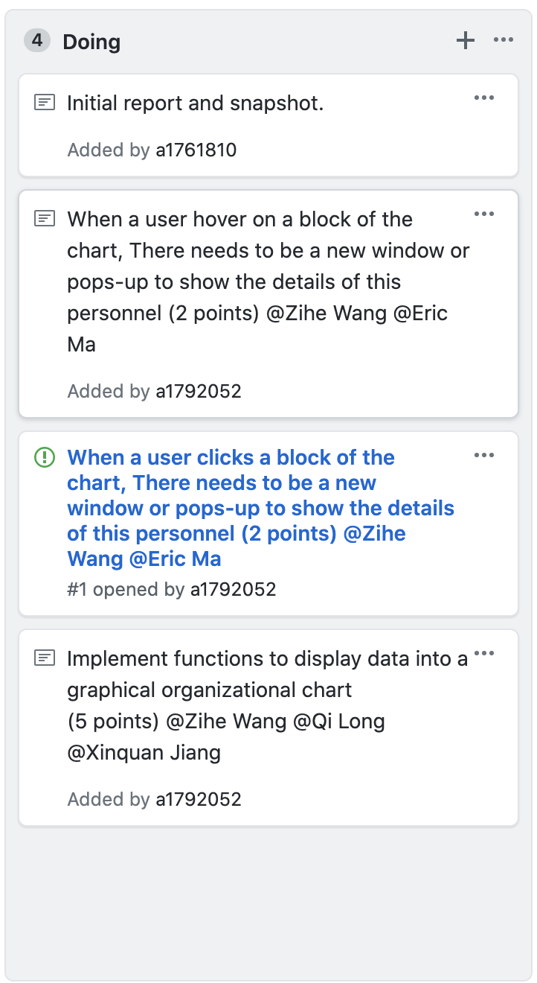

Done:

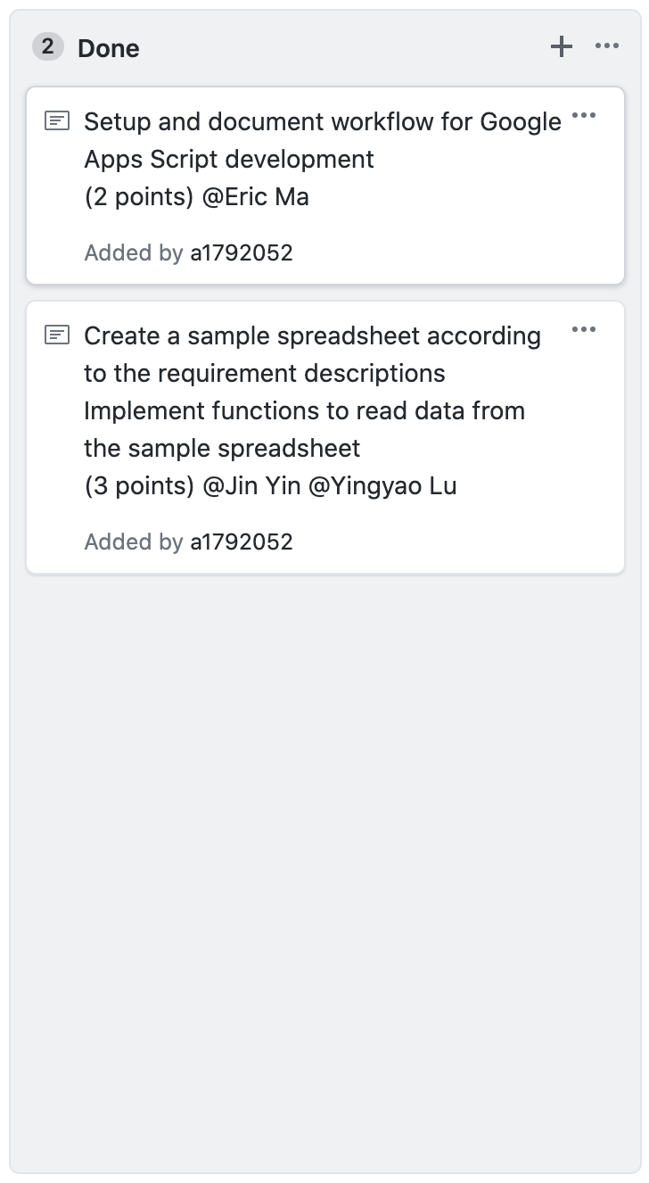

**Sprint Backlog and User Stories:**

Sprint backlog:

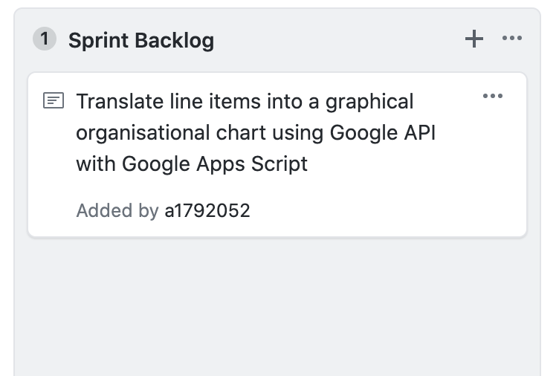

Description of the user stories:

Users need to have a function that can show the content as a graphical organisational chart. In this chart, the company structure, departments, and personals can be shown directly. *In addition, users are able to conveniently search information of staff who are from different departments or different locations, say by name, etc. Finally, admin users are able to generate reports in predefined formats,*

**Definition of Done**

Line items can be translated into a graphical organizational chart. All the test information is based on the sample google spreadsheet.

* Complete Coding editing
* Peer reviewed
* Performance test is complete
  + Read line items (shown in the following figure) correctly.

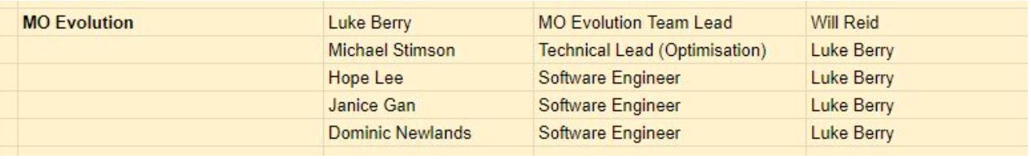

* + Parse the staff information into correct attributes.
  + Show the graph correctly including the position, organization structure, staff information etc as follows.
  + 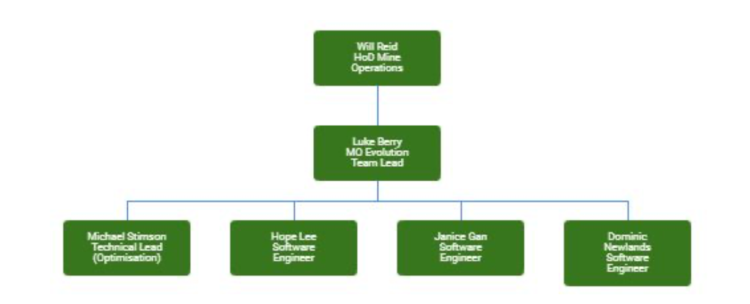

* Technical documentation is complete
* The customer sign-off to confirm their requirement is satisfied.

**Summary of Changes:**

The first Snapshot.